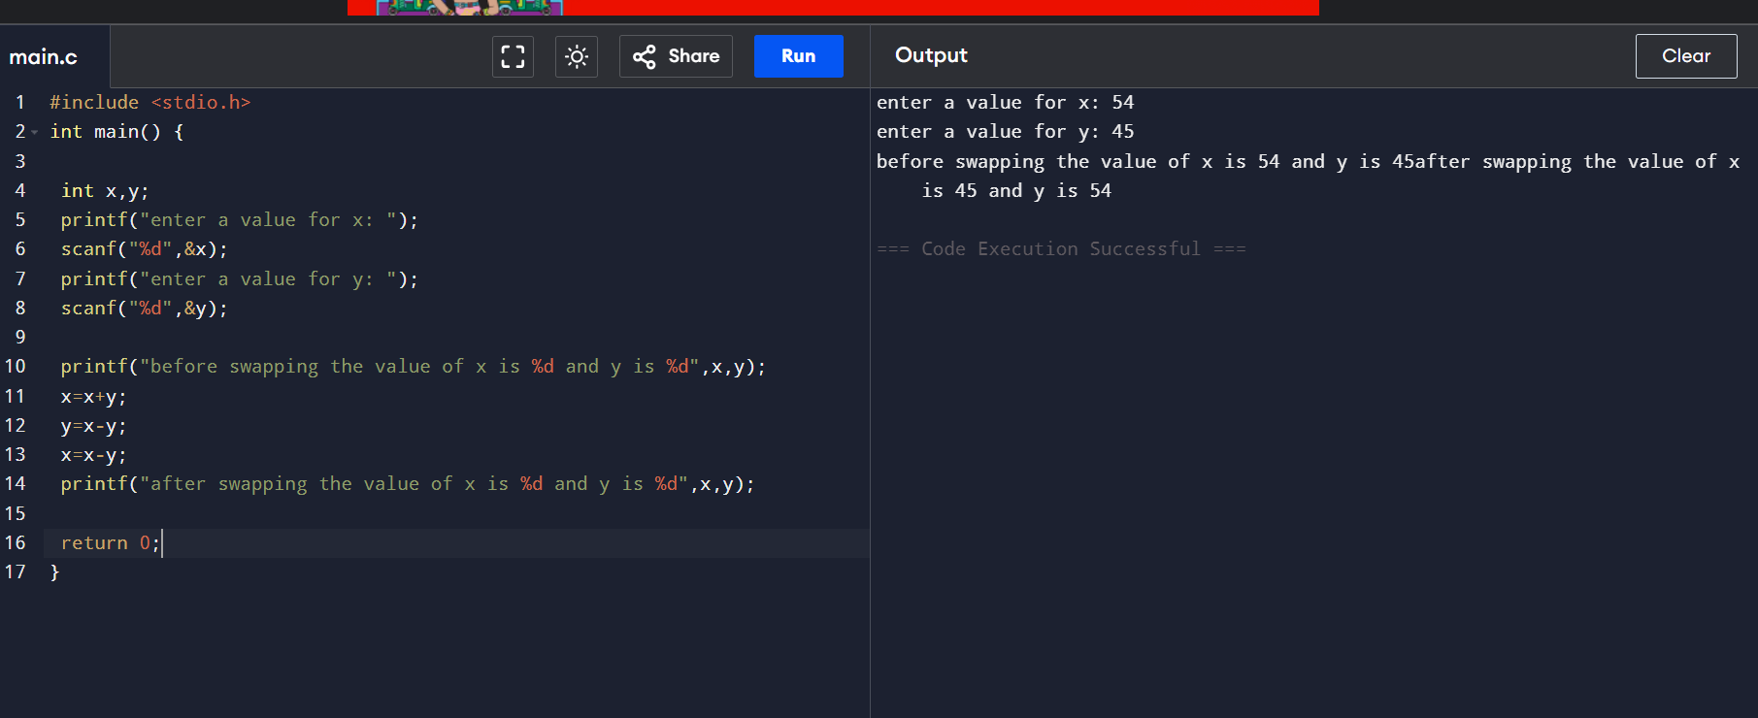

GOKUL CHAWLA
12525176
CAP 173

